**Smart Device Windows Client Usage Guide**

**Document version： V1.11.2**

**Secret level： External disclosure**

# Revised record

|  |  |  |
| --- | --- | --- |
| Revised date | version number | revision note |
| 2018/6/5 | V1.0 | First edition |
| 2018/8/1 | V1.1 | Update usage instructions according to the latest version of the client. |
| 2018/12/25 | V1.2 | Update usage instructions based on the latest version of v1.11.2 client |
|  |  |  |

catalog

Revision record 2

One、Introduction 4

Two、Applicable platforms and considerations 4

Three、Client installation 4

Four、Client usage guide 9

# One、brief introduction

This paper is a guide for AXON RGBD camera windows client to guide users how to view camera effect (including depth image, IR infrared image, RGB image) through windows client and save depth data through client.

# Two、Applicable platform and matters needing attention

This client is suitable for Windows7 and above.

Refer to the documentation for problems during installation: smart device installation and Diagnostic Guide.

The RGBD camera power supply (5V/6A) must be connected correctly and the USB cable must be connected to the computer.

This guide applies to client versions of AXON_Client V1.11.2 and above.

# Three、Client installation

1.Depending on the use of the platform, select the appropriate installation package, such as legend for installation

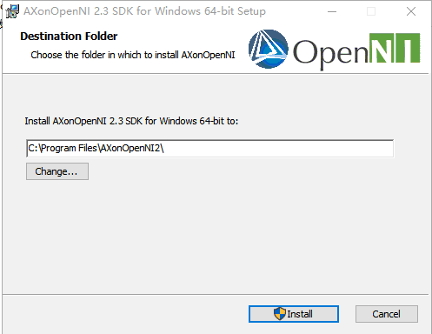

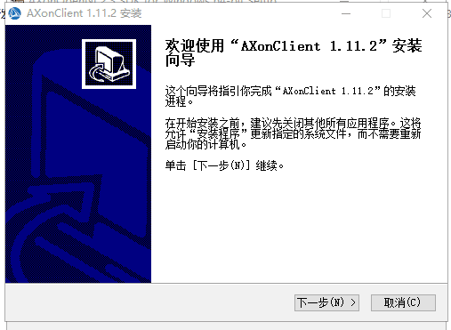

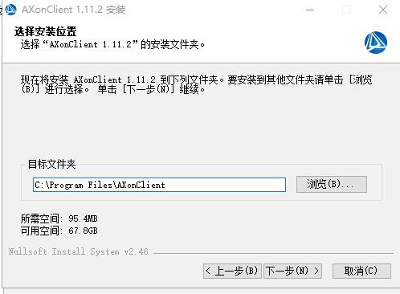

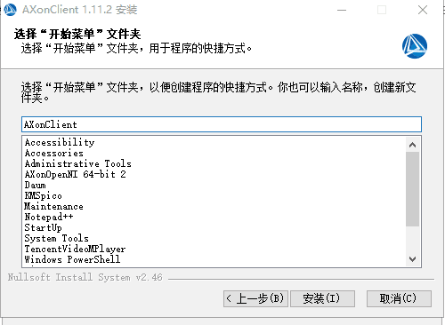

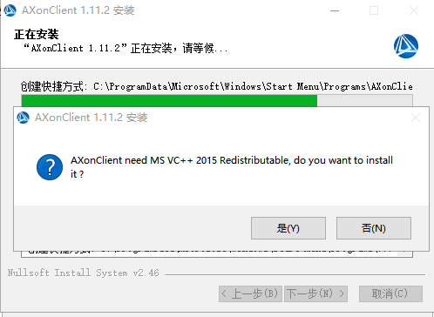

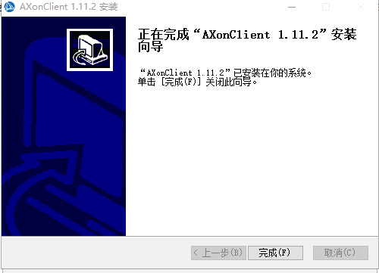

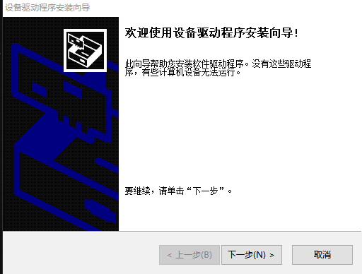

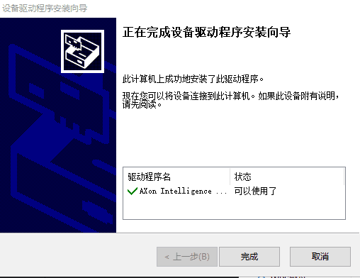

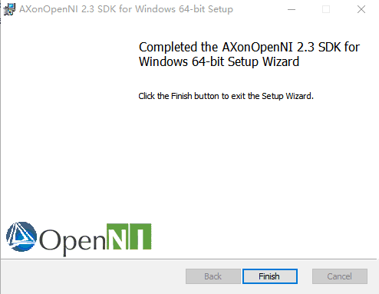

At this point, the installation is complete.

# Four、 Client's User's Guide

1、Open Client: Under the "AXonClient" folder (default is "C: Program FilesAXonClient ") double - click" AXON - Client "executable. ：

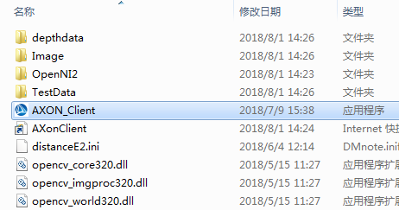

图1 安装包文件所在位置

2、After the client opens, the default display interface is as follows, the device usb interface is connected, and after the normal connection, click the "Connect Select camera" button.：

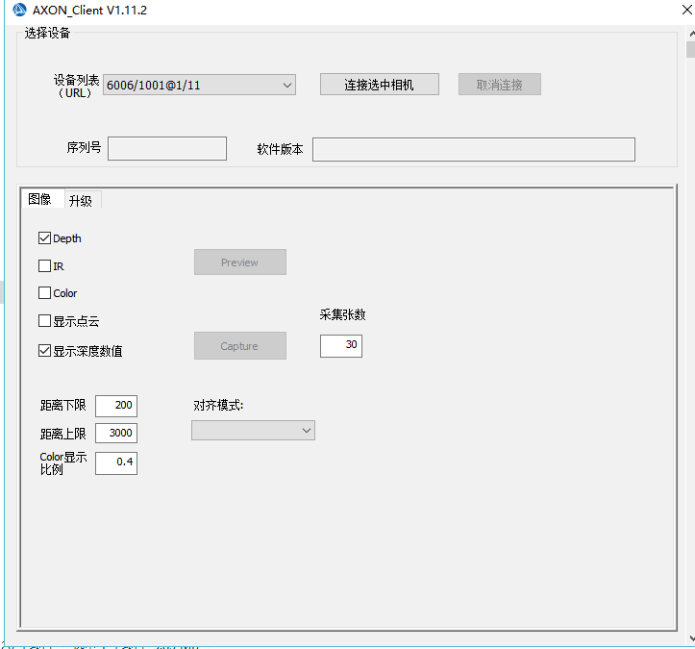

Picture2 Interface and default options when the software is opened

3、The device usb interface is connected, and after the normal connection, click "connection check camera", the button will display the device serial number and software version at the bottom of the device list, and the "Preview" and "Capture" buttons will change from unclickable to clickable.

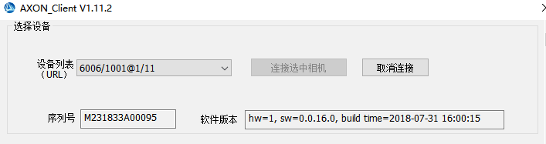

picture3.1 Display effect after clicking "Connect selected camera"

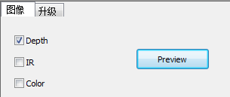 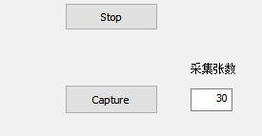

picture3.2 “Preview””Capture”Location of the button

Note：If the pop-out dialog box or view does not appear, check that the power and USB lines are plugged in, or choose to restart the machine.

4、By default, the client checks "Depth" and clicks "Preview" to display the depth map. The depth map is expressed by color information, the distance is expressed in warm color in the spectrum when the distance is close, and the cold color is expressed in the far away.

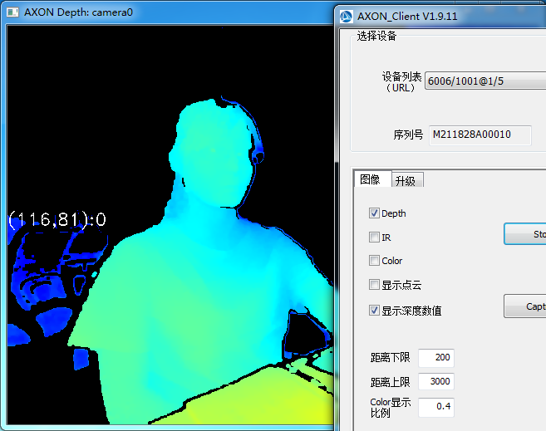

picture4 When "Depth" is checked, the effect diagram displayed by the camera

5、When the mouse moves to the depth image area, a series of numbers are displayed. When the mouse is placed in the red circle area of the depth image, the depth information is displayed from left to right with the upper left corner as the coordinate origin (x, the coordinate axis information of y): z, the data unit is the distance data of the actual test.

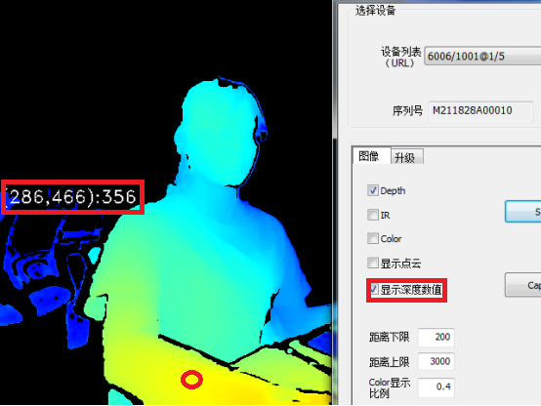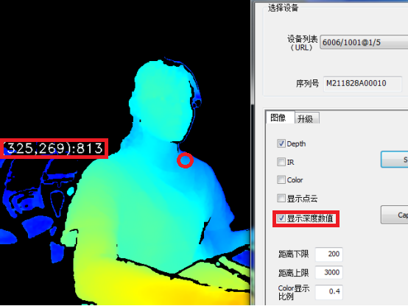

picture5 Data information displayed by different location points

6、The lower limit of distance and the upper limit of distance only refer to the range of distance shown in the depth map and do not affect the actual detection distance of the device.

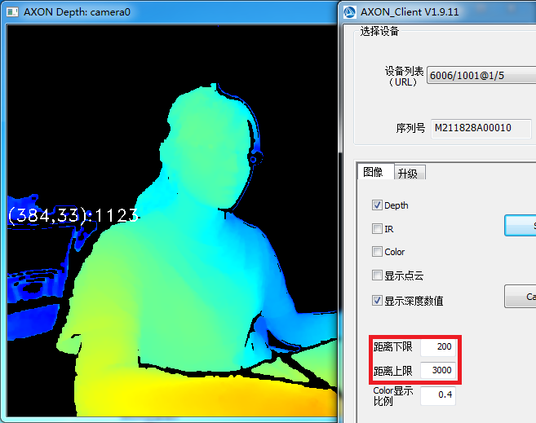

picture6.1 The distance and proximity of 0.2 m shows the effect diagram.

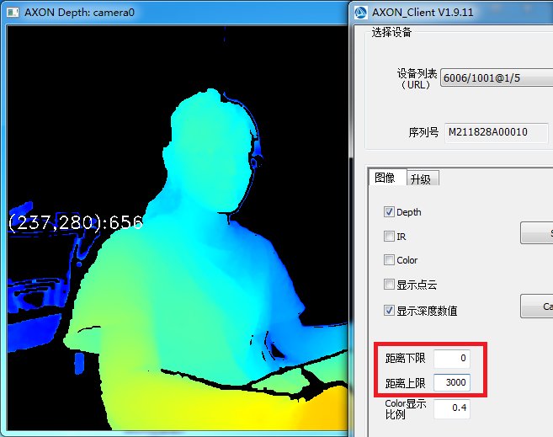

picture6.2 0 / 3 m display color effect map

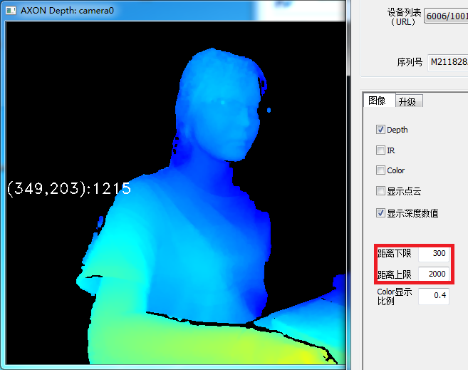

picture6.3 The near-and-far display effect diagram of 0.3 -2 m

7、"IR" displays infrared view; "Color" displays RGB view; "Show point cloud", when all checked, the point cloud data is superimposed with IR image, as shown in the figure below.

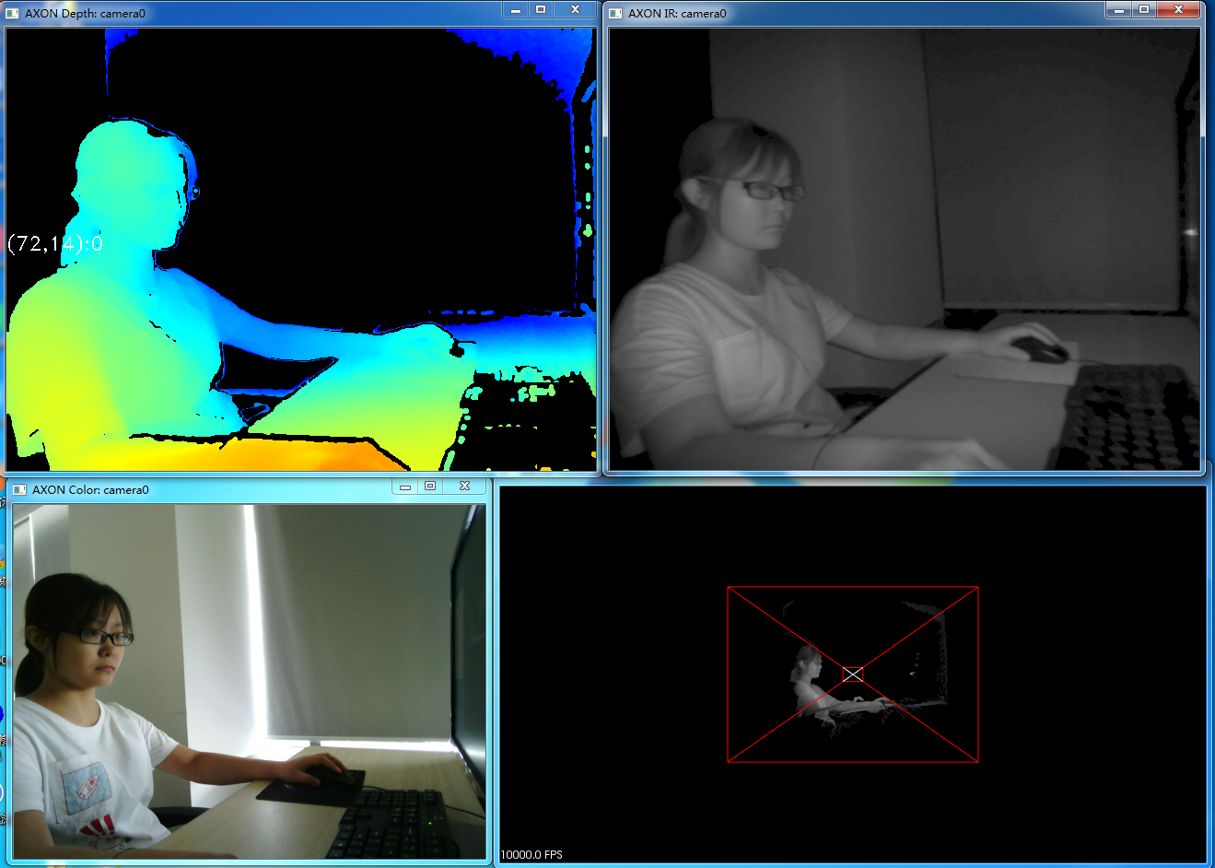

picture7 Four-view effect diagram

8、When "Preview" is selected, click to select the "color" option box on the right, which will jump out of the "AXON color" display box and display the color RGB image; remove the "IR" check option, and the point cloud data in the point cloud display box will superimpose the Color image.

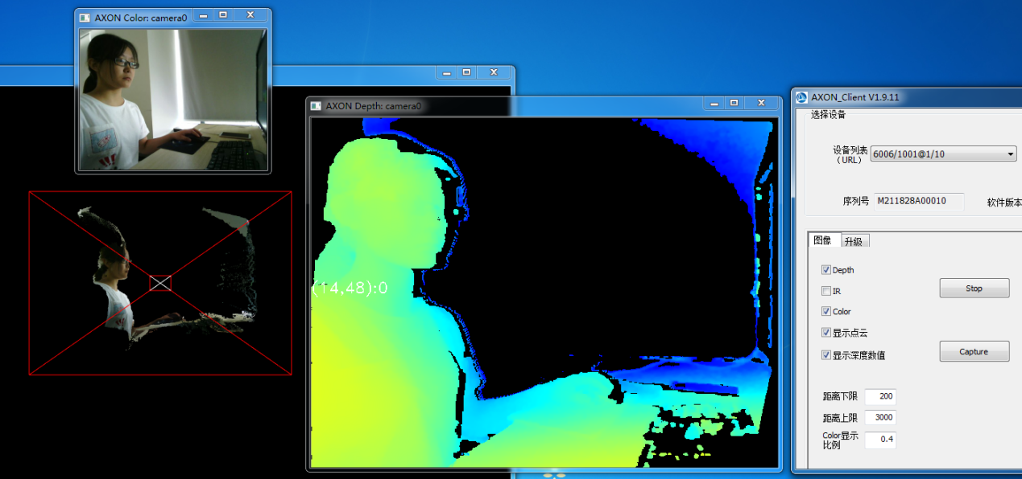

picture8 Point cloud superimposed Color effect diagram

9、When the "Depth" is checked with the "Preview" option box at the same time, the point cloud image is as shown in the figure：

Note：If you check Show Point Cloud but do not check "Depth," click the "Preview" button and there is no image display.

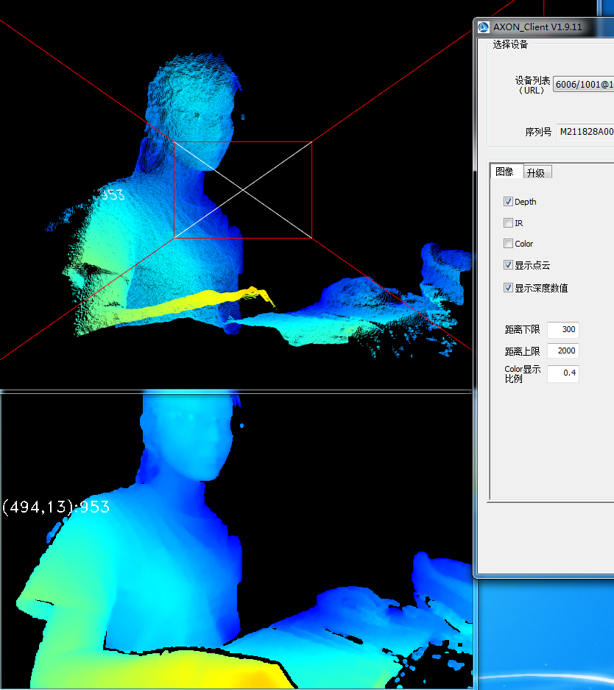

picture9 Basic point cloud map

10、Adjust the point cloud angle of view: the mouse moves to the point cloud display window "AXON PointCloud" range, the roller slips up and down to adjust the display image size, the roller scrolls up and magnifies the image, and scrolls down to reduce the image.

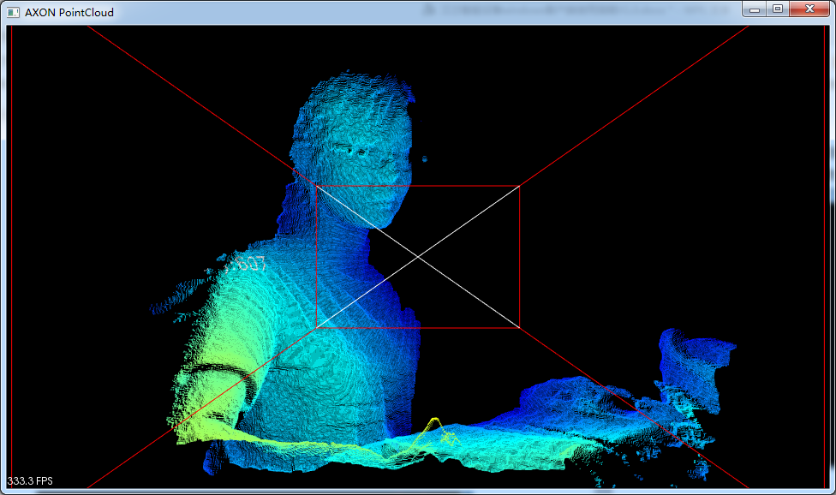

picture10.1 Roller upward sliding point cloud magnification map

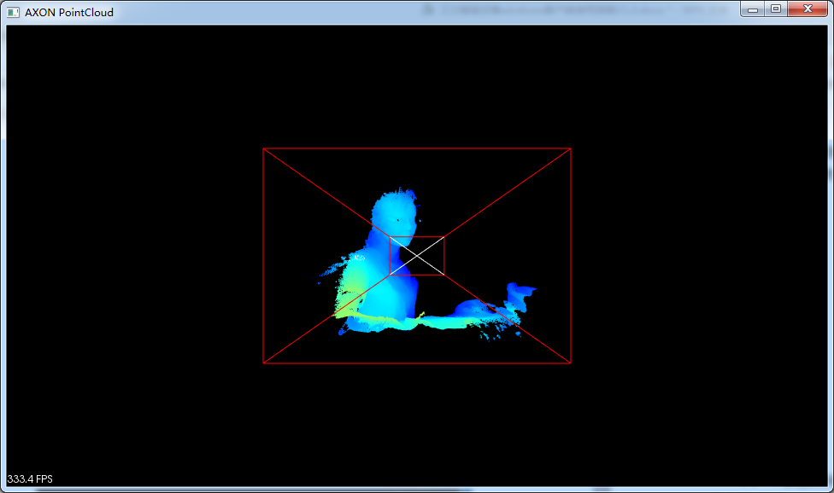

picture10.2 Roller downward sliding point cloud reduction diagram

Note：Holding down the roller can move the point cloud image in plane, and holding down the right mouse button can also enlarge and shrink the point cloud image.

11、Hold down the left button of the mouse, drag the mouse up and down to rotate the point cloud angle of view, you can rotate to a suitable angle as needed.

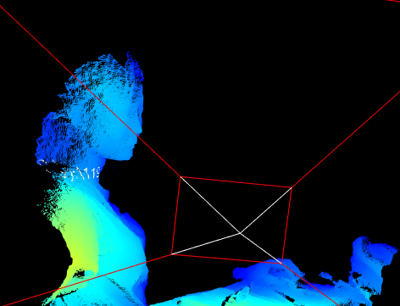

picture11 Point cloud map rotation side view effect

12、Get the depth data through the client: Enter the number of depth maps that need to be captured in the dialog box to the right of the "Capture" button, and click the "Capture" button to save the depth image data. The "Save Complete" dialog box will pop up after the data is saved.

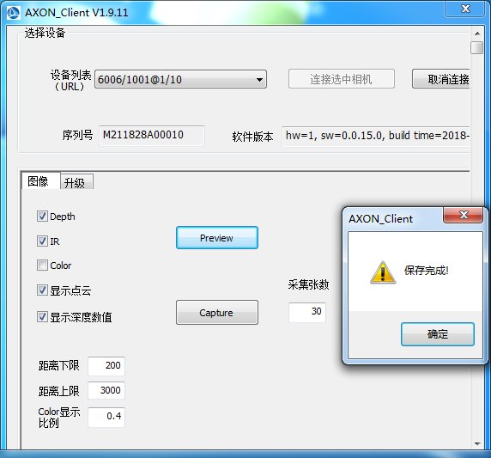

picture12 Successful effect of image preservation

13、The data saved by Depth,IR,Color is in the "AXON Client\ Image" folder in the client directory, and the depth map is saved in PNG format. The data saved by the point cloud is in the AXONClient\ depthdata\ pointCloud folder in the client directory. The point cloud is saved as ".asc"; through Matlab and other point clouds, the data can be processed by the common processing software of depth map.

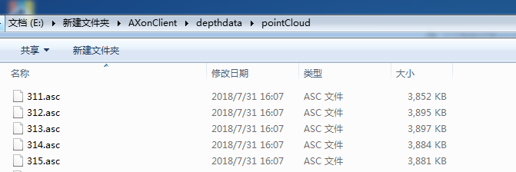

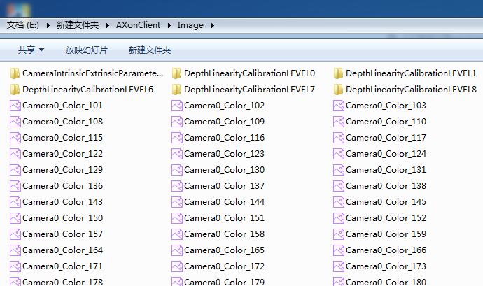

picture13 Location and format of crawling data storage

Note：The client is installed in the system disk directory, there is no data when saving the data, please note that the program has the permission to write files when the program runs; if you need to save the data, you can "run as an administrator" program.

1. alignment function Off

Alignment function turned off

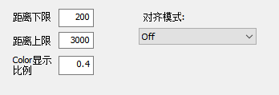

（2）Depth to Color

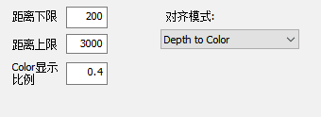

Align depth data into the rgb coordinate system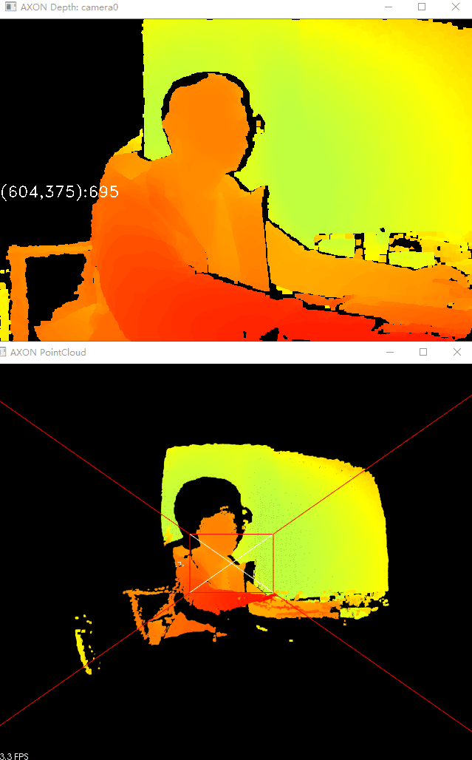

（3）Depth&IR to Color

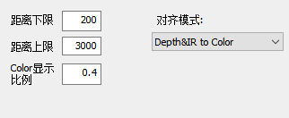

Align the depth data with the infrared image (grayscale image) into the rgb coordinate system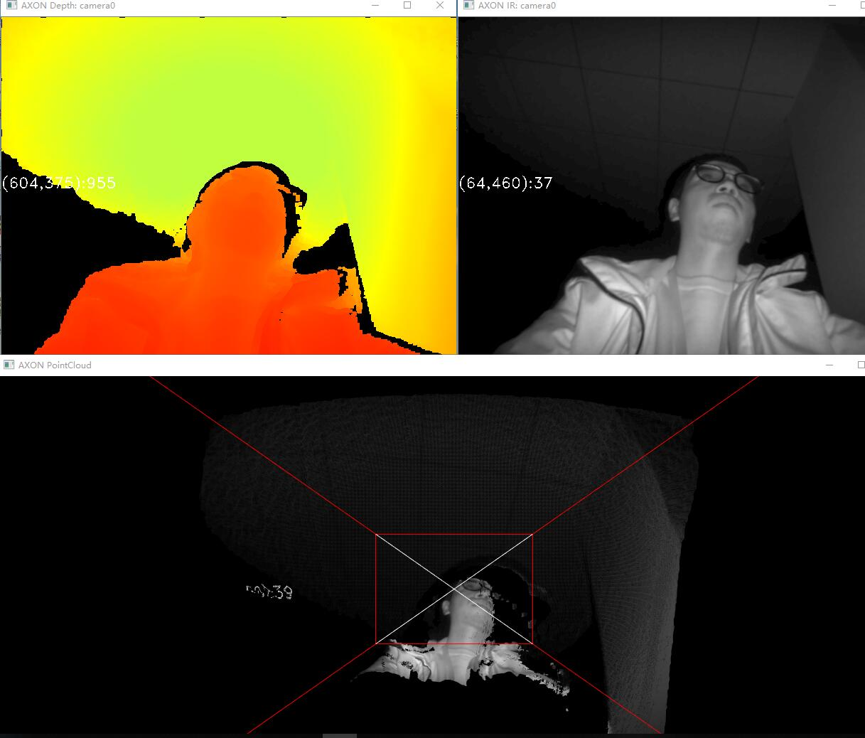

1. Color to Depth
2. Align the rgb diagram into the coordinate system of the depth map.

Distortion correction mode

